EEEE2065 Lab 1: Energy Usage Tracker
Student ID: 20715019 | Module: EEEE2065 | Academic Year: 2026/27

1. Introduction
This report describes a C++ program that tracks the daily energy usage of exactly three household devices from my own daily routine. For each device the program reads a name, a usage time in hours per day and a power rating in watts. It then calculates the daily energy usage in kWh, sorts the devices with a custom rule and prints a formatted table. My student ID (20715019) is appended to every device name, as required by the brief.
The program is split across three files, which is main.cpp, a file that calls the functions in order to test the class. Device.h which stores declaration of the Device class and the functions used by main(). Device.cpp which has all definitions, including input validation helpers, sorting and display.

2. Design Plan: Decomposition into Classes and Functions
The task was broken into small pieces, each with one responsibility: input, calculation, sorting, display and cleanup. The below table shows each function and its responsibility.
Component | Type | Responsibility
Device | Class | Stores name, power (W) and hours/day. Calculates energy and prints its own table row.
readNumber() | Helper (private to device.cpp) | Prompts repeatedly until the user enters a valid number inside a given range.
readName() | Helper (private to device.cpp) | Prompts repeatedly until a non-empty name is entered.
inputDevices() | Function | Loops over the devices, collects validated input and creates each Device with new.
sortByEnergy() | Function | Orders the pointer array by daily energy, highest first.
displayDevices() | Function | Prints the table header and separator, then asks each device to print its row.
deleteDevices() | Function | Frees every dynamically allocated Device.
main() | Driver | Calls the functions in a logical order: input, sort, display, delete.
Program flow: input → sort → display → free memory. Each stage is a separate function, so any stage can be changed or tested without touching the others. The helper functions sit inside an unnamed namespace so they are only visible in device.cpp. This keeps the public interface in device.h small.
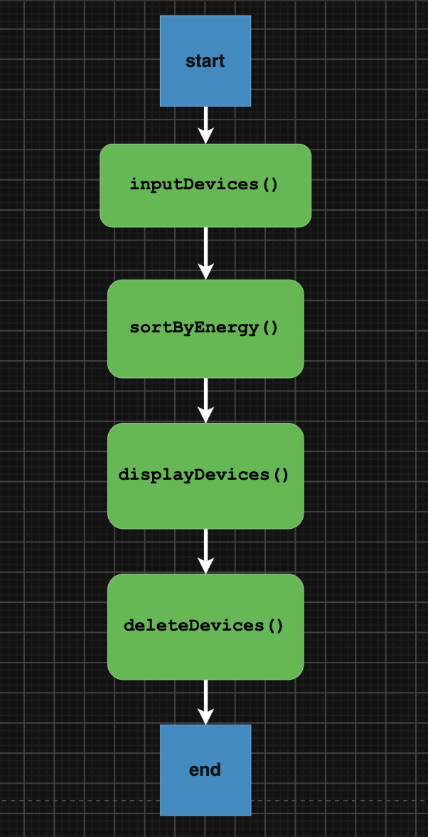

3. Class Design: the Device Class
The Device class groups the attributes of a device with the operations that act on them. Private attributes: std::string name, double powerWatts, double hoursPerDay. Keeping the data private means it can only be changed through the class, which protects it from accidental modification (encapsulation). Constructor: Device(const std::string& n, double p, double h) initialises all attributes using an initialiser list. The name is passed by const reference to avoid an unnecessary copy. dailyEnergyKWh() const: returns (powerWatts * hoursPerDay) / 1000.0. It is marked const because it does not modify the object. print(int number) const: prints one formatted table row, so the object is responsible for displaying itself.
The energy calculation lives inside the class rather than in main(). This avoids duplicated formulas and means that sorting and display always use the same calculation.

4. OOP Principles Used

4.1 Modularity
Every function has one clear job (see the table in Section 2). Input handling, sorting, display and memory management are independent. The declarations are in the header file and the definitions in the source file, so main.cpp only needs #include "device.h".
  - Scalability

The number of devices is controlled by a single constant, NUM_DEVICES in main.cpp. All functions take a count parameter, so none of them contain a hard-coded 3. The table layout is controlled by named width constants (W_NO, W_NAME, W_POWER, W_HOURS, W_ENERGY). Changing the spacing means editing one value. New attributes (for example a room, a cost per kWh or a standby power) can be added as extra members of Device and printed in print() without changing the structure of the program. A different sorting rule can be added by writing another function with the same signature as sortByEnergy() and calling it from main().

  - Robustness (error handling)
User input is read as a whole line with getline() and checked before it is accepted. This prevents the usual cin problems such as a stuck input stream after letters are typed. readNumber() converts the text with stod() inside a try/catch block. The value is accepted only if the whole line was consumed (pos == line.size()) and it lies within the allowed range. Input such as abc, 5x, an empty line or nan is rejected, and the user is asked again. Hours per day must be between 0 and 24. Power must be at least 0.1 W, so a zero or negative rating cannot be entered. readName() rejects empty names. The error message changes depending on whether the input has an upper limit, so the user is always told what is expected. deleteDevices() releases all heap memory, so the program does not leak memory.

4.4 Classes and pointers
The devices are stored in an array of Device* pointers (Device* devices[NUM_DEVICES]) and each object is created with new in inputDevices(). Because the array holds pointers, passing it to a function does not copy any Device objects. The sort also only swaps pointers instead of copying whole objects, which is cheaper. Every new has a matching delete in deleteDevices(), which is called once at the end of main().

4.5 Code recycling
readNumber() is used for both hours and power, with different ranges passed in as arguments, so the validation logic is written only once. The print() method is reused for every row of the table.

5. Tokens, Identifiers and Data Types
Concept | Examples from the code
Keywords | class, private, public, const, void, double, int, for, while, if, return, new, delete, namespace
Identifiers | Device, powerWatts, hoursPerDay, dailyEnergyKWh, inputDevices, NUM_DEVICES, STUDENT_ID (camelCase for variables and functions, UPPER_CASE for constants)
Literals | "Name: " (string), 1000.0 (floating point), 24 (integer), '-' (character)
Operators | *, /, +, <, <=, >=, ==, &&, ->, ::, <<, >>
Punctuators | { }, ( ), [ ], ;, ,
Data types | std::string for names, double for power, hours and energy, int for counts and loop indices, size_t for string positions, Device* for pointers
Constants | const int NUM_DEVICES, const std::string STUDENT_ID, const double NO_LIMIT = numeric_limits<double>::max()
double was chosen for power and hours because real devices can have fractional values (for example 0.25 hours of microwave use per day). int is used wherever a whole number is needed, such as counts and loop indices.

6. Custom Sorting Rule and Justification
My devices are sorted by daily energy consumption in kWh, from highest to lowest. The device that uses the most energy appears first. The aim of an energy tracker is to show where energy is used. Sorting by energy puts the biggest consumer at the top, which is the first device someone should look at to reduce their usage. Daily energy depends on both power and hours (E = P × t / 1000). Sorting by power alone or by hours alone could be misleading. For example, a 1200 W microwave used for 15 minutes a day can use less energy than a 65 W laptop used for 8 hours. Because the list is already ranked, the row number printed in the table also serves as a ranking (1 = highest consumer), so no extra column is needed. The implementation of the sorting is sortByEnergy() uses a bubble sort. Neighbouring pointers are compared using dailyEnergyKWh() and swapped when the left one is smaller than the right one. The comparison is a strict <, so devices with equal energy keep their original relative order. Bubble sort is simple, easy to explain and entirely adequate for three items. For a much larger list, std::sort with a comparison function would be more efficient.

7. Testing and Evaluation
The program was compiled with g++ -Wall -Wextra and run with valid and invalid input. The test devices below must be replaced with my own three devices before submission, and each "Observed result" should be confirmed against a screenshot.

7.1 Normal operation
Device (example) | Hours/day | Power (W) | Expected energy (kWh/day)
Laptop | 8 | 65 | 0.52
Airpod | 0.25 | 1200 | 0.30
Phone charger | 5 | 20 | 0.10
Expected output order: Laptop (0.52), Microwave (0.30), Phone charger (0.10), with 20715019 appended to each name.

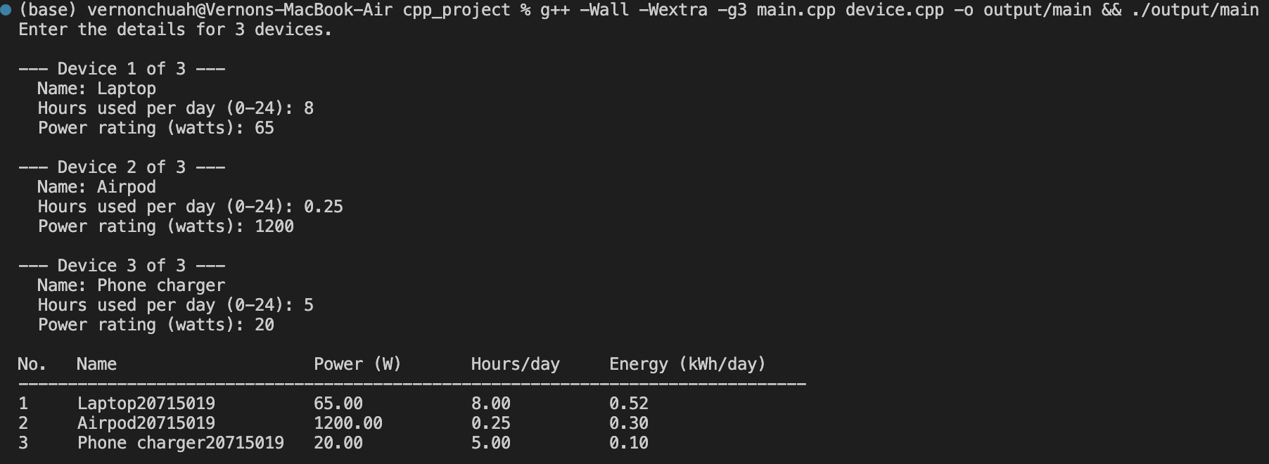

7.2 Invalid input tests
# | Test | Input | Expected behaviour
1 | Empty name | (press Enter) | "Name cannot be empty." and prompt repeats
2 | Text instead of number | abc for hours | Error message, prompt repeats
3 | Number followed by text | 5x for hours | Rejected, prompt repeats
4 | Hours too large | 25 | Rejected (valid range 0 to 24)
5 | Negative hours | -3 | Rejected
6 | Zero power | 0 for watts | Rejected (minimum 0.1 W)
7 | Negative power | -50 | Rejected
8 | Boundary values | 24 hours, 0 hours | Accepted
9 | Decimal values | 0.25 hours | Accepted and calculated correctly
10 | Equal energy | Two devices with the same kWh | Original order is kept

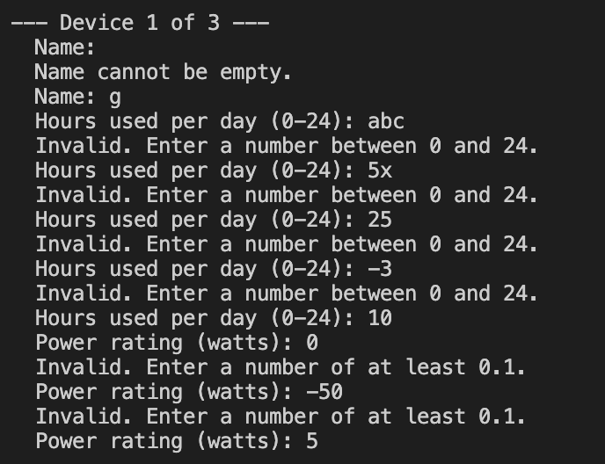

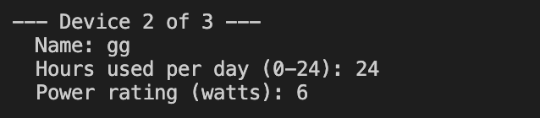

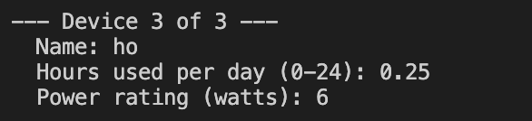

7.3 Evaluation
The program compiles without warnings, and the calculated energy values match hand calculations. All invalid inputs in the table above are rejected without crashing, and the user is asked again. Memory is released at the end of the program.

8. Limitations and Possible Improvements
Very long device names can be wider than the name column, which shifts the later columns. The width could be increased or long names truncated. Raw pointers need a manual delete. Using std::vector<std::unique_ptr<Device>> would free memory automatically and remove the fixed array size. Getter functions (for example getName()) could be added so that other parts of the program can read the data without printing it. Extra features could include total daily and monthly energy, a cost estimate and saving results to a file.

9. Conclusion
The program meets the brief. It accepts the name, power rating and usage hours of three devices and stores them as Device objects managed through pointers. It adds my student ID to each name and sorts the devices by daily energy use, highest first. The design is modular, easy to extend and handles invalid input without failing. The custom sorting rule makes the output directly useful for finding which device uses the most energy.

